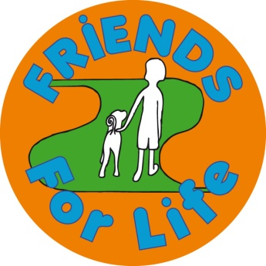
FRIENDS
What is FRIENDS?
- 10 week long, manualised, school based programme
- 1-2 hours each week
- Process and structure important
- Shared understanding – home and school
- Recommended by the World Health Organization

Underpinning theory: CBT
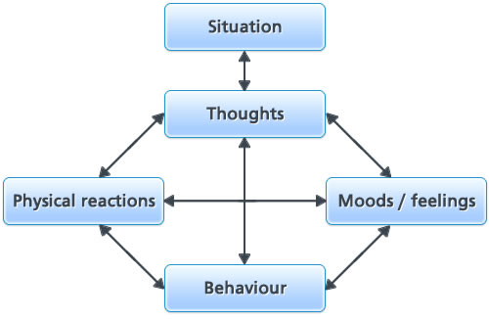
- CBT approaches are effective as both a prevention and treatment of childhood anxiety (Fisak, Richard, & Mann, 2011; Neil & Christensen, 2009)

- FRIENDS dominates reviews

- Evidence of theoretical concepts which it aims to change?

The evidence
- Barrett and Turner (2001) - Significant post-intervention reductions in anxiety
- Lowry- Webster, Barrett & Dadds (2001) - Intervention group reported fewer anxiety symptoms, regardless of their risk status, than the comparison group at post- test.
- Lowry- Webster, Barrett & Lock (2003) - Maintained at 12 month follow up as measured by self-reports and diagnostic interviews.
- Lock & Barrett (2003) - Primary school children reported greatest changes in anxiety symptoms
- Barrett, Farell, Ollendick & Dadds (2006) - Reductions in anxiety reported in Lock and Barrett were maintained for primary students. Preventative?

UK- based
- Stallard, Simpson, Anderson, Hibbert & Osborn (2007) - Significant reduction in anxiety 3 months following intervention
- Stallard, Simpson, Anderson & Goddard (2008) - 12 month follow up – reduced anxiety maintained for both whole group and high risk group. Preventative?
- Liddle and Macmillan (2010) - Reduction in anxiety which was maintained at four month follow up

Systematic reviews
- Briesch, Hagermoser Sanetti, and Briesch (2010) “research to date suggests that FRIENDS may be a promising intervention for the treatment of anxiety in school based settings” p.163.

- Maggin and Johnson (2014) “the research underlying school-based versions of the FRIENDS program presently lacks the rigor to certify it as an evidence-based practice”

